Activity Report: The Coding Triathlon
Aivolutions – Official Society of Department of CSE (Artificial Intelligence)
Maharaja Agrasen Institute of Technology, Rohini, New Delhi
Date: 23rd – 25th March 2025

Department | Computer Science & Engineering (Artificial Intelligence)
Activity Category | Workshop / Expert Talk / Quiz Competition / Coding Challenge
Title of Activity | The Coding Triathlon
Theme / Focus Area | Technical Proficiency | Coding Skills | Logical Reasoning | Agentic AI
Society / Club | Aivolutions – Official Society of AI
Academic Year | 2025-2026

- Basic Details
Dates of Activity | 23rd March 2025, 24th March 2025, 25th March 2025
Duration | Three Days | Morning: 10:00 AM – 12:00 PM | Afternoon: 2:00 PM – 4:00 PM (Days 1 & 2)
Venue / Platform | Laboratory,11th Block Room no. 1146, MAIT, Rohini, New Delhi
Organized by | Aivolutions – Official Society of AI, Dept. of CSE (AI), MAIT
Faculty Coordinator | Dr. Nitin Garg
Head of Department | Dr. Vinay Kumar Saini

Number of Participants:
Day | Student Participants | Faculty Present | External Guests
Day 1 – 23rd March | 63 | Present | Mr. Sandeep & Mr. Deepak (DUCAT)
Day 2 – 24th March | 48 | Present | Nil
Day 3 – 25th March | 56 | Present | Nil

- Resource Person / Speaker Details (Day 1 – DUCAT Industry Session)
Name(s) | Mr. Sandeep & Mr. Deepak
Designation | Industry Expert / Senior Trainer
Organization | DUCAT Institute of Information Technology, Noida
Area of Expertise | Agentic AI, Large Language Models, AI Tooling & Automation
Brief Profile | Mr. Sandeep and Mr. Deepak are experienced IT professionals and trainers at DUCAT, one of India's leading technology training institutes. They have mentored engineering students and industry professionals in AI, Machine Learning, and enterprise-level AI deployment. Their expertise encompasses the design of AI agents, LLM-based tool integration, and practical deployment of autonomous AI pipelines.

- Objectives of the Activity
  - To provide students with a multi-day platform integrating theoretical concepts with practical coding challenges, fostering technical development beyond the prescribed curriculum.
  - To expose participants to industry-relevant technologies — specifically Agentic AI, Large Language Models, and AI-driven automation — through a dedicated expert-led session by DUCAT professionals.
  - To strengthen collaborative, competitive, and problem-solving aptitudes through structured activities including a GitHub-based relay, a real-time Kahoot quiz, and a systematic bug bounty challenge.
  - To cultivate a culture of innovation by designing progressive difficulty levels across three days, culminating in a high-stakes competitive final.
  - To recognise and reward outstanding performers, reinforcing a merit-driven academic environment within the society.
Description of the Activity
"The Coding Triathlon" was a three-day flagship technical event conceptualised and executed by Aivolutions — the Official Society of Artificial Intelligence at Maharaja Agrasen Institute of Technology — held from 23rd to 25th March 2025. The event was designed as a progressive challenge series in which each day introduced a distinct technical dimension, escalating in complexity and competitive intensity as participants advanced from one day to the next. Consistent attendance exceeding 60 participants per session reflected the strong engagement of the student community.

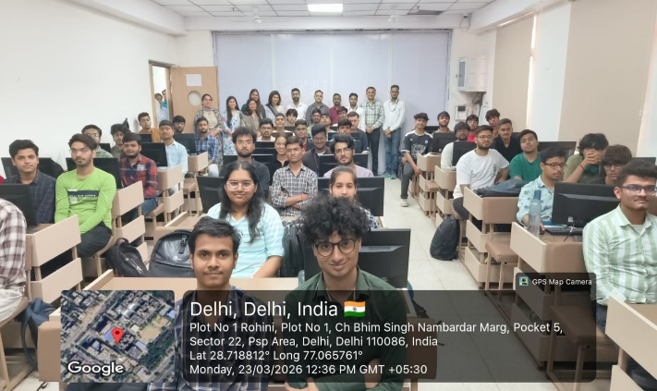
Day 1 – 23rd March 2025:
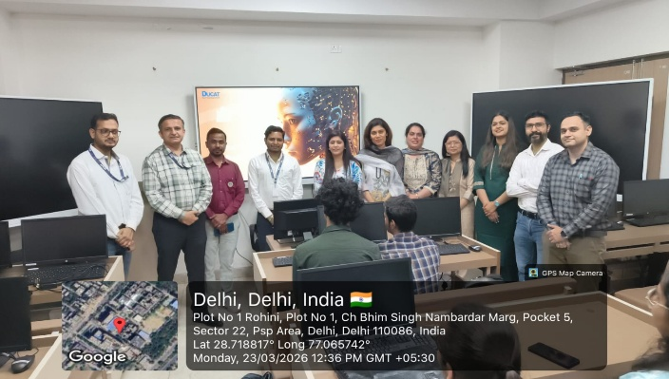
The inaugural day was divided into two sessions. The morning session (10:00 AM – 12:00 PM) featured the GitHub Relay, a collaborative team-based activity designed to reinforce practical version control skills. Participants worked in groups to complete a series of Git and GitHub tasks spanning repository creation, branching strategies, pull request workflows, conflict resolution, and collaborative code commits. This relay format injected an element of spirited competition while reinforcing industry-standard software development practices that are often underrepresented in undergraduate coursework.
The afternoon session (2:00 PM – 4:00 PM) featured an industry-academia interaction conducted by Mr. Sandeep and Mr. Deepak from DUCAT, who delivered a technically rich session on Agentic Artificial Intelligence. Participants were introduced to the architecture of AI agents, the role of tool-calling mechanisms within LLM frameworks, and real-world deployment scenarios of autonomous AI pipelines. A significant highlight of this session was a live hands-on demonstration in which students interacted directly with an AI chatbot interface, observing agent-driven responses and tool integration in real time. The session bridged classroom concepts with industry realities, generating substantial interest among attendees.

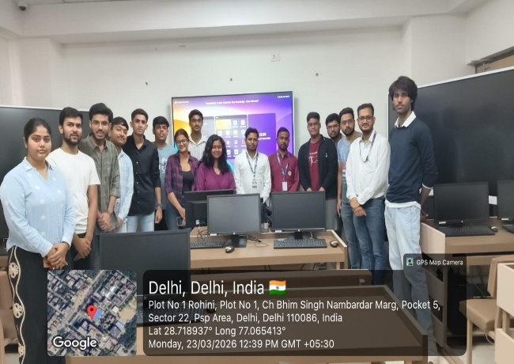 | 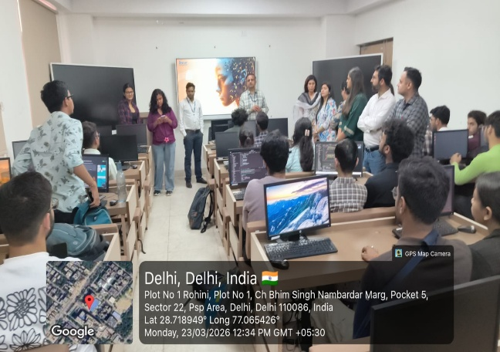

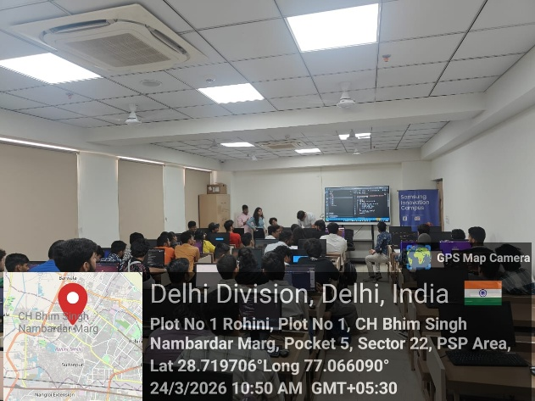
Day 2 – 24th March 2025:
The second day comprised two sessions of high-octane technical engagement. The morning session (10:00 AM – 12:00 PM) hosted a Kahoot-based live Quiz Competition spanning a broad spectrum of technical topics including Data Structures & Algorithms, Operating Systems, Computer Networks, Database Management Systems, Artificial Intelligence, Web Technologies, and current affairs in the technology domain. The gamified format — with real-time leaderboards, time-bound questions, and competitive scoring — created an atmosphere of intellectual rivalry that encouraged students to test conceptual understanding beyond their syllabi.
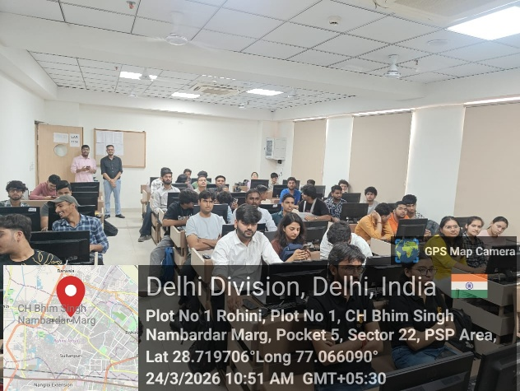
The afternoon session (2:00 PM – 4:00 PM) featured the Bug Bounty Challenge, a practical debugging exercise simulating real-world software quality assurance scenarios. Participants were presented with code snippets and mini-applications embedded with intentional logical, syntactical, and runtime errors across multiple technology stacks including Python, JavaScript, and SQL. The objective was to identify, analyse, and articulate bugs within a stipulated timeframe. This session honed critical thinking, code review discipline, and systematic debugging methodologies — competencies indispensable in professional software development roles.
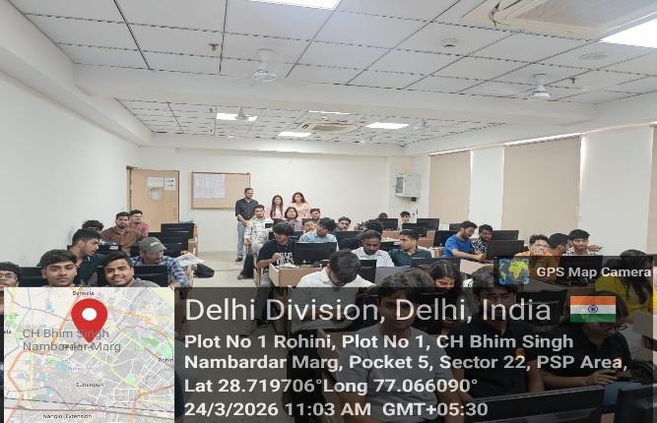 | 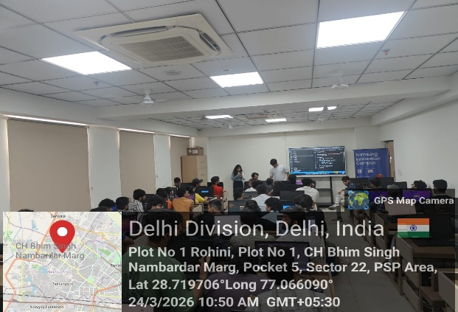

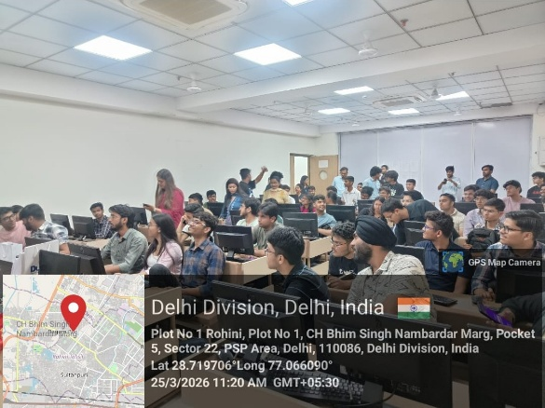
Day 3 – 25th March 2025:
The final day served as a grand culmination of the event series (10:00 AM – 12:00 PM), drawing together the most competitive participants for a decisive final showdown. The session introduced a Level-Up format — a multi-tiered challenge structure in which each successive round escalated in difficulty, requiring participants to demonstrate both breadth of technical knowledge and depth of problem-solving acuity. Quiz battles blended logical reasoning, algorithm analysis, AI concepts, and rapid-fire coding challenges within a single unified competitive framework.
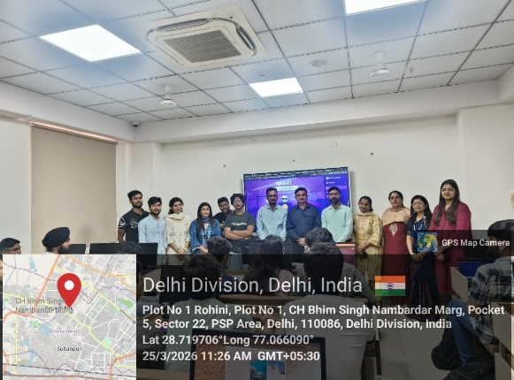
The Level-Up progression added a strategic dimension: participants had to manage accuracy, time, and risk intelligently as challenge stakes increased with each tier. The event concluded with a formal prize and medal distribution ceremony in the presence of the Faculty Coordinator, Dr. Nitin Garg, and the Head of Department, Dr. Vinay Kumar Saini. A closing address by the society leadership acknowledged the organising team and expressed appreciation for the student community's participation throughout the three-day event.
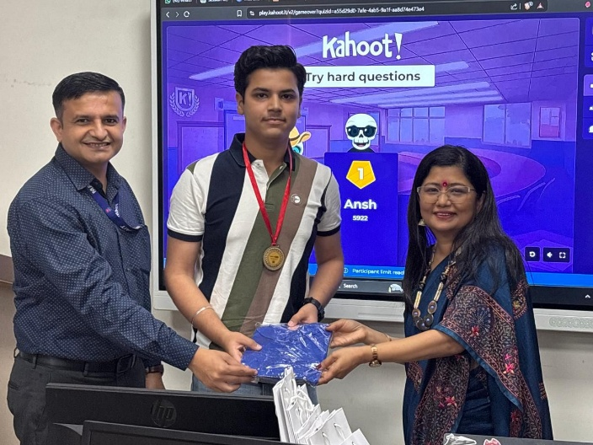 | 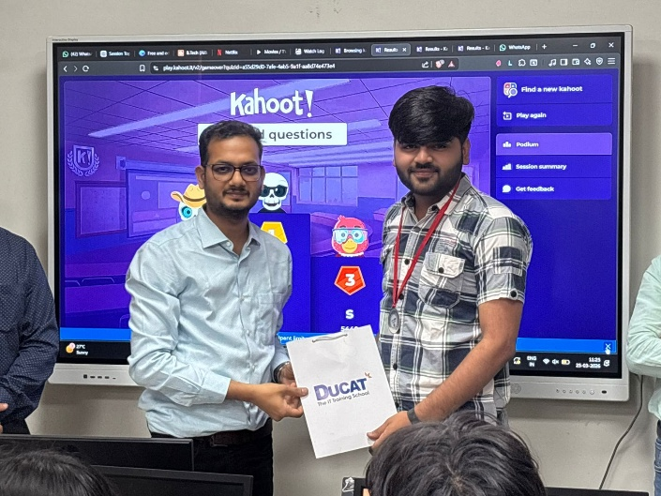
- Learning Outcomes / Impact Technical Skills Acquired:
  - Practical proficiency in Git and GitHub workflows — branching, merging, pull requests, and collaborative commits.
  - Foundational understanding of Agentic AI architectures, LLM-based tool-calling, and AI chatbot interaction paradigms.
  - Systematic debugging and code review skills across Python, JavaScript, and SQL.
  - Reinforced knowledge of core Computer Science subjects (DSA, DBMS, OS, CN, AI) through competitive application.
Cognitive and Professional Development:
  - Strengthened logical reasoning and analytical thinking through time-pressured, multi-domain problem-solving.
  - Improved ability to perform under competitive conditions — managing accuracy and speed simultaneously.
  - Exposure to industry-standard development practices through the GitHub Relay, instilling software engineering discipline.
Awareness and Innovation Mindset:
  - Increased awareness of the rapidly evolving landscape of Artificial Intelligence, specifically autonomous AI agents.
  - Fostered an innovation-oriented and competitive spirit, encouraging self-directed learning beyond the academic syllabus.
  - Reinforced the value of collaborative development by simulating real-world team-based software engineering environments.
- Feedback Summary
Feedback Mode | Google Form (shared post-session via QR code) / Written feedback forms
Average Rating | To be updated upon compilation of responses (Expected: 4.2 / 5.0 or above)
Key Insights | Participants identified the GitHub Relay and Agentic AI session as the most impactful components. The Kahoot format was widely appreciated for making technical revision engaging. Multiple respondents expressed interest in further industry interaction sessions and more advanced coding challenges in future editions.
- Challenges Faced
  - Coordinating schedules for external resource persons from DUCAT required advance planning and multiple rounds of communication to finalise timing and content alignment.
  - Managing technical infrastructure for live Kahoot sessions — including stable internet connectivity and device availability for 60+ participants — necessitated prior preparation and on-spot troubleshooting.
  - Maintaining uniform engagement across a large participant pool required effective facilitation, rotational activity design, and real-time moderation by society coordinators.
  - Designing bug bounty questions at varying difficulty levels across multiple programming languages required significant pre-event effort from the technical committee.
- Recommendations / Future Scope
  - The Coding Triathlon model is recommended for adoption as an annual flagship event of Aivolutions, with incremental enhancements in scope and industry participation each edition.
  - Future iterations could incorporate team-based project sprints or short hackathon segments to elevate collaborative creation alongside individual competitive performance.
  - Integration of live coding platforms such as LeetCode or HackerRank for automated judging would provide a more standardised and scalable competitive experience.
- Annexures
  - Annexure I – Attendance Sheets
  - Annexure II – Event Poster / Brochure
  - Annexure III – Participant Feedback Summary
  - Annexure IV – Geo-tagged Photographs (minimum 9, 3 per day)
  - Annexure V – Prize & Medal Distribution Record

Report Prepared By | Verified By | Approved By
Dr. Nitin Garg  Assistant Professor  Signature:  Date: | Dr. Vinay Kr. Saini  HOD, CSE-AI  Signature:  Date: | Prof. (Dr.) Vikram Bali  Director, MAIT  Signature:  Date:

